Green Kilometre
Scheme 2024

Kildare County Council

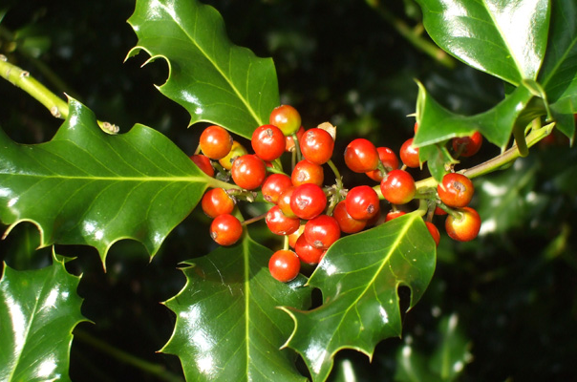

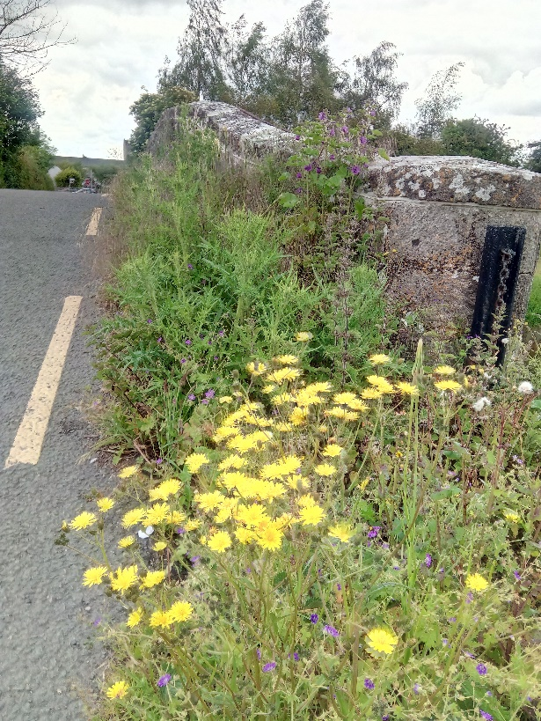

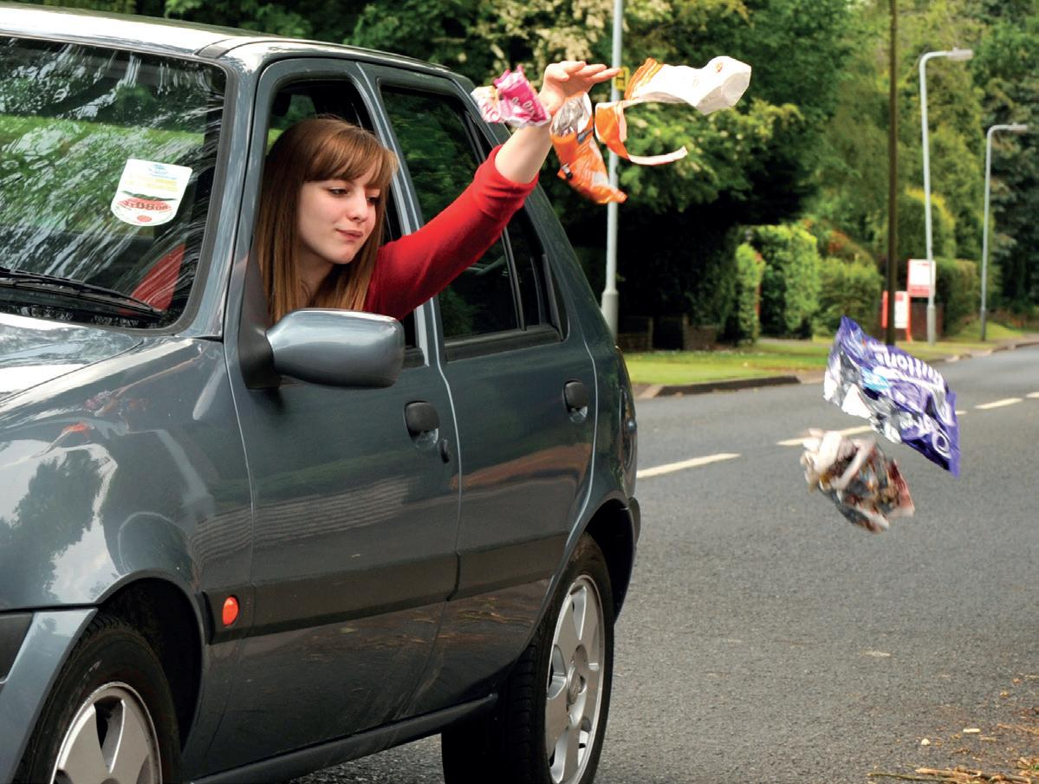

Reduce Litter and Help Wildlife!

Helping your community.

Kildare County Council is aware that there are many groups and individuals around the county who would like to contribute to their local community. An increase in walking and cycling in the last number of years has made many people aware of both the litter that may be seen along the roadside, but also the wildlife that exists in the hedgerows and roadside margins. Supports are available for Tidy Towns and residents associations in the town and villages, so it is important to also support people in rural areas who want to take action on litter and wildlife. With over 2,500 kilometres of roads in the county, there are plenty of opportunities to get involved!

Adopt A Kilometre
So, we are asking groups and individuals to choose approximately one kilometre of rural road in their area- preferably a quiet, local road in terms of safety. The group or individual would then work on the chosen kilometre over the course of the year. The scheme is a means of encouraging participation in looking after a local area.
All participants are offered some native trees and shrubs. If the participant wants these, they can be planted back into the hedgerow, with the landowners’ permission. By removing litter and helping native hedgerows you are playing an important part in helping the environment. The planting even helps to mitigate against climate change. Equally importantly, it is an opportunity for you and your community to work together on a project that benefits everybody. Actions may include:
- Removing litter

- Restoring heritage features such as old farm gates or walls.
Permission from landowners should be obtained first and protected structures should only be maintained following professional advice.

- Reporting illegal dumping

- Planting appropriate native trees and shrubs

- Improving hedges (sections of traditional hedgelaying would be very welcome)
Hedgecutting is banned from March 1st to September 1st.

Applications can be submitted at any time of the year

If you collect more than a bag of litter, the council will collect this by arrangement- use the removal of waste form at the end of this document and tick the Green Kilometre section. Typically if we receive a form for a cleanup on a Saturday, we will collect the bags on the following Tuesday or Wednesday.

Useful Resources

To report illegal dumping where there is potential evidence (in the dumped waste or a vehicle registration or other identifier), tel.: 045 980588 or email environlitter@kildarecoco.ie

Learn about the placename for your area: www.logainm.ie

Identify native wildflowers: www.wildflowersofireland.net

Find out about the National Pollinator Plan www.pollinators.ie

Identify invasive species such as Japanese knotweed: www.invasivespeciesireland.com

Learn about hedgelaying (traditional hedgecutting): www.hedgelaying.ie

Manage waste and find out where to recycle www.mywaste.ie

Discover more about Kildare’s built heritage
and grants for conserving local heritage: www.kildare.ie/countycouncil/AllServices/Heritage/

Kildare County Council
Green Kilometre Scheme 2024 Application Form

Name of group or individual:________________________________________________________

Contact name:_________________________________________________________

Contact tel.:__________________________________________________________

Contact email: _________________________________________________________

Eircode_______________________________________________________________
Area where Green Kilometre is located (please use sketch map overleaf, we may not be familiar with the exact area)

____________________________________________________________________

____________________________________________________________________

___________________________________________________________________

Works planned:

Litter picking

Hedges trimmed

Verges cut

Other (please specify)___________________________________________________

____________________________________________________________________

____________________________________________________________________

____________________________________________________________________

Would you like to receive some native trees and shrubs? Y/N___________________
(these are typically holly, spindle, guelder rose, oak but availability will vary)

Optional sketch map of Green Kilometre Area

Please identify landmarks, road names etc. as we may not know the area (map can be sketched and photo and application can be emailed to above address)

Forms can be emailed to environawareness@kildarecoco.ie or posted to:

Environment section, Kildare County Council, Áras Chill Dara, Devoy Park, Naas, Co. Kildare W91 X77F

Requesting refuse bags and litter-pickers for community cleanups
PLEASE NOTE, BAGS AND LITTER PICKERS CAN BE COLLECTED FROM YOUR LOCAL MUNICIPAL DISTRICT OFFICE. CALL THEM IN ADVANCE TO ENSURE THEY HAVE SOME IN STOCK.

The following are contact numbers for Municipal District Offices;

Athy MD
Rathstewart, Athy 045 980203

Kildare/Newbridge MD
Newbridge Industrial Estate 045 437556

Maynooth MD
Leinster Street, Maynooth 01 6286236

Celbridge/Leixlip MD
Leinster Street, Maynooth 01 6286236

Naas MD (Environment section)
Aras Chill Dara, Devoy Park 045 980588

APPLICATION FORM FOR REMOVAL OF LITTER AND WASTE FROM COMMUNITY CLEANUPS CAN BE FOUND HERE:

Kildare County Council - Environment

(located at www.kildare.ie/countycouncil/environment/forms ).

- Green waste, (including LEAVES, grass clippings, sods, soil & hedge cuttings) cannot be taken as this scheme is only for the removal of collected litter and illegally dumped waste.

- All waste must be bagged- loose waste, with the exception of large items will not be collected.

- A secure location is required for temporarily storing the waste to prevent illegal dumping where waste is left for collection.

Groups are entitled to two collections a year (typically one in spring and one in autumn). This is to ensure all groups can avail of this scheme. More collections can be accommodated by arrangement.

